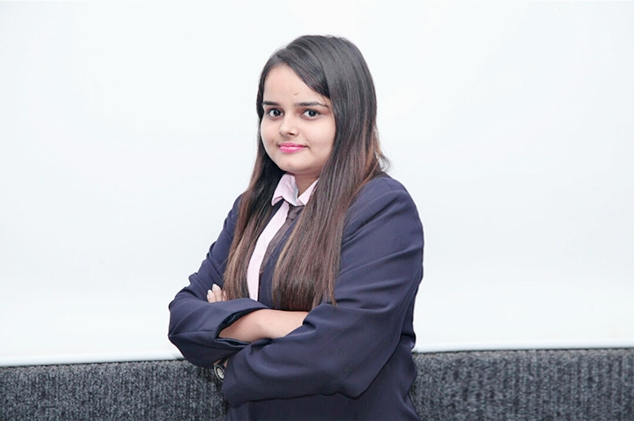

* B.Tech, CSE
* To secure a position where I can efficiently contribute my skills and abilities to the growth of the organization.
* <ENTHUSIAST DESCRIPTION>

I HAVE WON THE THIRD PRIZE IN 1ST  SEMESTER FOR AN ‘IR MODEL’ . I HAVE ALSO PARTICIPATED IN THE MRIU MODEL UNITED NATIONS (MUN) WHICH PLAYED A BIG ROLE IN ENHANCING MY COMMUNICATION SKILLS .

RIYANSHI MITTAL

PROJECTS & ACCOLADES

* ON-GOING PROJECT WITH JP TOKYO & CO
* 2 PUBLISHED RESEARCH PAPERS   
  2 Research papers have published in IEEE conference and IJERT journal.
* COMMUNICATION   
  I have good speaking skills and can communicate well.
* APTITUDE   
  I perform well in quantitative and qualitative aptitude .

SKILLS & STRENGTHS

**riyanshimittal_mriirs@outook.com**

**Ms. Charu virmani**

I AM A HARD WORKING , CARREER ORIENTED PERSON .

I AM GOOD AT QUANTITATIVE AND QUALITATIVE APTITUDE FOR WHICH I HAVE BEEN AWARDED THE FIRST PRIZE IN SEMESTER 4 . I HAVE ALSO BEEN FALICITATED FOR THE FOREIGN LANGUAGE WE ARE BEING TAUGHT , FRENCH FOR SHOWING OUTSTANDING PERFORMANCE.

GET TO KNOW ME THROUGH MY EYES OF THOUGHTS